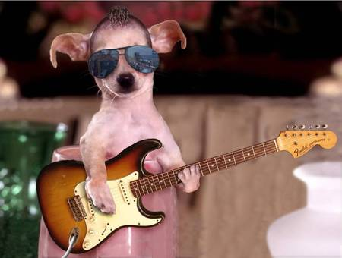**FREESOUND**

presents

GRINNELL DAY SHOW

CENTRAL PARK

**SATURDAY 5/10**

**12 – 5 PM**

*free hot dogs and carnival games*